PROJECT-II REPORT
On

ONLINE MID DAY MEAL PROGRAM

Submitted to Rajasthan Technical University
in partial fulfillment of the requirement for the award of the degree of

B.TECH.

in

COMPUTER ENGINEERING

Submitted By
Krishan Kumar Sharma (PIET15CE051)
Mahesh Kumar ( PIET15CE057)
Aayush Kumar Gupta ( PIET15CE0002)

Under the Guidance of
Mr. Punit Mathur

at



POORNIMA INSTITUTE OF ENGINEERING & TECHNOLOGY, JAIPUR

Rajasthan Technical University, KOTA

APRIL, 2018

CERTIFICATE
This is to be certified that the project entitled “ Medicine Recommendation Based on Age, Gender and Physical Attributes” has been submitted for the Bachelor of Computer Science and Engineering, Poornima Institute Of Engineering & Technology, Jaipur during the academic year 2018-2019 is a bonafide piece of project work carried out by “ Krishan Kumar sharma , Mahesh kumar & Aayush Kumar Gupta” towards the partial fulfillment for the award of the Degree (B.Tech.) under the guidance of “Prof. (Dr.) Punit Mathur” and supervision and no part of thereof has been submitted by them for any degree or diploma.

Project Guide Project Coordinator Mr. Deepak Moud
Prof. (Dr.) Punit Mathur Prof. (Dr.) Praveen Gupta (H.O.DCSE)
(Assistant Professor) (Professor)

CANDIDATE’S DECLARATION

We, Krishan Kumar Sharma (PIET15CE051), Aayush Kumar Gupta( PIET15CE002) & Mahesh Kumar( PIET15CE057) B.Tech (Semester- VII) of “Poornima Institute Of Engineering & Technology, Jaipur” hereby declare that the Project Report entitled “ Medicine Recommendation Based on Age, Gender and Physical Attributes” is an original work and data provided in the study is authentic to the best of our knowledge.This report has not been submitted to any other Institute for the award of any other degree.

Krishan kumar sharma | Aayush Kumar gupta | Mahesh kumar
piet15ce051 | piet15ce002 | piet15ce057

Place: | Jaipur
Date: | 23/10/18

ACKNOWLEDGEMENT

It is our pleasure to be indebted to various people, who directly or indirectly contributed in the development of this work and who influenced our thinking, behavior and acts during the course of study.
We express our sincere gratitude to Dr. O. P. Sharma, Director, PIET for providing us an opportunity to undergo this Major Project as the part of the curriculum.
We are thankful to Mr. Deepak Moud, HOD, CS for his support, cooperation, and motivation provided to us during the training for constant inspiration, presence and blessings.
We are thankful to Prof. (Dr.) Punit Mathur for his support, cooperation, and motivation provided to us during the training for constant inspiration, presence and blessings.
We also extend our sincere appreciation toProf. (Dr.) Praveen Gupta who provided his valuable suggestions and precious time in accomplishing our Project report.
Lastly, we would like to thank the almighty and our parents for their moral support and friends with whom we shared our day-to-day experience and received lots of suggestions that improved our quality of work.

Krishan Kumar Sharma | Aayush Kumar Gupta | Mahesh Kumar
PIET15CE051 | PIET15CE002 | PIET15CE057

TABLE OF CONTENTS

CHAPTER NO. | TOPICS | PAGE NO.
 | TITLE PAGE | I
 | CERTIFICATE | II
 | CANDIDATE’S DECLARATION | III
 | ACKNOWLEDGEMENT | IV
 | TABLE OF CONTENTS | V
 | TABLE OF FIGURE | VI
 | ABSTRACT | VII
1 | INTRODUCTION TO PROJECT | 10
 | Project Aim and Objective  Problem Statement  Background of the Project (Literature Survey)  Software Requirements  Hardware Requirements | 10  11  13  14  15
2 | PRODUCT BACKLOG | 16
 | - PRODUCT Backlog  - Sprint Backlog-1  - Sprint Backlog-2  - Sprint Backlog-3  - Sprint Backlog-4 | 16  17  18  19  20
3 | TECHNOLOGY APPLIED AND PROJECT MANAGEMENT | 21
 | Brief Description of All technology Apply in the Project.  Project management  Agile  Relevance to Society  Ethics  Life Long Learning  Project Finance  Environment and Sustainability | 21  25  27  31  36  40  45  48  57
4 | PROJECT IMPLEMENTATION | 60
 | Sprint Backlog-1  Sprint Backlog-2  Sprint Backlog-3  Sprint Backlog-4 | 61  62  65  68
5 | CONCLUSION | 69
 | Results  Conclusion  Future Scope | 69  70  73
6 | ANNEXURES | 75
 | References | 75
 | APPENDIX/ANNEXURES
 | Research Paper ( if Presented and approved for publication)
 | CV

LIST OF FIGURES

S. NO. | FIGURE | PAGE NO.
2.1 | Product Backlog | 16
2.2 | Burn Chart | 17
2.3 | Sprint Backlog 1 | 18
2.4 | Sprint Backlog 2 | 19
2.5 | Sprint Backlog 3 | 20
2.6 | Sprint Backlog 4 | 21
3.1 | Machine Learning | 42
4.1 | Data collection | 60
4.2 | Take top most values | 60
4.3 | Graphic view of the data | 61
4.4 | Plot Correction | 62
4.5 | Uniformying the data type of the features | 63
4.6 | Splitting the data | 64
4.7 | Training of the data | 65
4.8 | Random forest | 66
4.9 | Testing Regression | 67

LIST OF TABLES

S.NO. | Table | Page No.
3.1 |  | 32-33

ABSTRACT

KEYWORDS:
Abstract Integrated Healthcare Limited was launched in 2001 to develop, own and, where appropriate, manage Primary care facilities. Besides developing new medical centres, Abstract, through its venture capital arm, was involved in the care home sector as an investor and is currently involved in Pharmacy2U, one of the first online pharmacies.
Our healthcare buildings are the product of close teamwork between us, our professional team and the end user and represent a wide cross-section of sizes and facilities, from the smallest, simplest medical centre to some of the most innovative and exciting developments in primary care today. We aim to produce good-looking, well-planned and energy-efficient solutions to provide the very best environment for patients, staff and visitors.
Abstract has developed medical centres in a number of locations in the UK and is currently involved with a number of new schemes which are at different stages of approval. Further details can be seen on our dedicated Healthcare website www.abstracthealthcare.co.uk

CHAPTER 1

INTRODUCTION TO PROJECT

Project Aim and Objective
An effective health care system is the one providing better personalized treatmentswith minimized cost. Medical expert systems are a branch of artificial intelligence that applies reasoning methods and domain specific knowledge to suggest recommendations like human experts. To enable reliable and fast decision-making process, medical expert knowledge needs to be stored as a knowledge based system(KBS). KBS alone is not sufficient to suggest reliable recommendations due to the limitations in updating expert rules based on the population studies and limited personalization.
Data driven approacheslike data mining and machine learning can be applied to extract insights from the heterogeneous data of the patients. It provides individual recommendations based on the past learning experience and the patterns extracted from clinical data. Combination of information retrieval and machine learning can be used for medical database classification.

Problem Statement
Medical practitioners use survival models to explore and understand the relationships between patient’s covariates (e.g. clinical and genetic features) and the effectiveness of various treatment options. Standard survival models like the linear Cox proportional hazards model require extensive feature engineering or prior medical knowledge to model treatment interaction at an individual level. While nonlinear survival methods, such as neural networks and survival forests, can inherently model these high-level interaction terms, they have yet to be shown as effective treatment recommender systems.
Personalized medicine, or more effective treatment based on individual health data paired with predictive analytics, is also closely related to better disease assessment. The domain is presently ruled by supervised learning, which allows physicians to select from more limited sets of diagnoses, for example, or estimate patient risk based on symptoms and genetic information. Personalized medicine (PM) aims to tailor disease prevention, diagnosis, and treatment to individuals based on their genes, lifestyle and environments. Patients and interested organizations may potentially play an important role in the realization of PM.

Background ofthe Project(Literature Survey)
PM relies on building statistical models able to predict personalized treatments, tailored to the characteristics of specific patients. In turn, developing such statistical models call for large amounts of patient data. However, in practice, patients often prefer not to divulge certain kinds of data due to privacy concerns.
Medical researchers use survival models to evaluate the significance of prognostic variables in outcomes such as death or cancer recurrence and subsequently inform patients of their treatment options. One standard full list of author information is available or related to the article survival model is the Cox Proportional Hazards model (CPH). The CPH is a semi parametric model that calculates the effects of observed covariates on the risk of an event occurring (e.g. ‘death’). The model assumes that a patient’s log-risk of failure is a linear combination of the patient’s covariates. This assumption is referred to as the linear proportional hazards condition. However, in many applications, such as providing personalized treatment recommendations, it may be too simplistic to assume that the log-risk function is linear. As such, a richer family of survival models is needed to better fit survival data with nonlinear log-risk functions.

Software Requirements
Python based Deep Learning libraries will be exploited for the development and experimentation of the project. Tools such as Anaconda Python, and libraries such as Tensorflow, and Keras will be utilized for this process. Training will be conducted on NVIDIA GPUs for training the SVM based naïve HRS, and advanced HRS.
- The Python Package Index lists thousands of third party modules for Python.

Web and Internet Development
- Python offers many choices for web development:
- Frameworks such as Django and Pyramid.
- Micro-frameworks such as Flask and Bottle.
- Advanced content management systems such as Plone and django CMS.
- Support for FTP, IMAP, and other Internet protocols.
- Easy-to-use socket interface.
- And the Package Index has yet more libraries:
- Requests, a powerful HTTP client library.
- BeautifulSoup, an HTML parser that can handle all sorts of oddball HTML.
- Feedparser for parsing RSS/Atom feeds.
- Paramiko, implementing the SSH2 protocol.
- Twisted Python, a framework for asynchronous network programming.

Scientific and Numeric
- Python is widely used in scientific and numeric computing:
- SciPy is a collection of packages for mathematics, science, and engineering.
- Pandas is a data analysis and modeling library.
- IPython is a powerful interactive shell that features easy editing and recording of a work session, and supports visualizations and parallel computing.
- The Software Carpentry Course teaches basic skills for scientific computing, running bootcamps and providing open-access teaching material

Hardware Requirements
If you’re trying to create value by using Machine Learning, you need to be using the best hardware for the task. With CPUs, GPUs, ASICs, and TPUs, things can get kind of confusing.
While for most of computing history there was only one type of processor, the wide growth of Deep Learning has led to two new entrants into the field: GPUs and ASICs. This post will walk through the different types of compute chips, where they’re available, and which ones are the best to boost your performance.
The OG processing unit was and is the CPU, first developed by Intel in the early 1970’s. The first ever processor was the Intel 4004 unit pictured below.
As time went on, CPUs grew and grew in their speed and capabilities. For some context, according to this Computer Hope article on the topic, “the first microprocessor was the Intel 4004 that was released November 15, 1971, and had 2,300 transistors and performed 60,000 operations per second. The Intel Pentium processor has 3,300,000 transistors and performs around 188,000,000 instructions per second.”
Singularity
Most processors were designed with one core (one CPU), which meant that it could only perform one operation at once. IBM released the first dual-core processor in 2001, which was able to “focus” on two tasks at once. Since then, more and more CPUs have been crammed into microprocessors: some modern supercomputers can have more than 40.
Even with recent advances, the fact remains that most computers only have a few cores at most. CPUs are designed for complex computations: they’re very good at rapidly parsing through a detailed and intertwined set of commands. And for most of the tasks a computer needs to do, like gasping for air in a sea of Chrome tabs, that’s exactly what you want. But with Machine Learning, things can get a bit different.

CHAPTER 2

PRODUCT BACKLOG

- PRODUCT Backlog :-
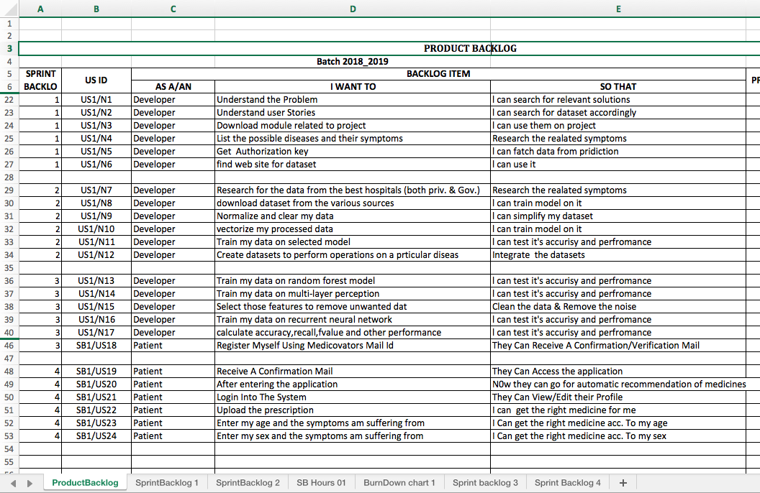
Figure 2.1

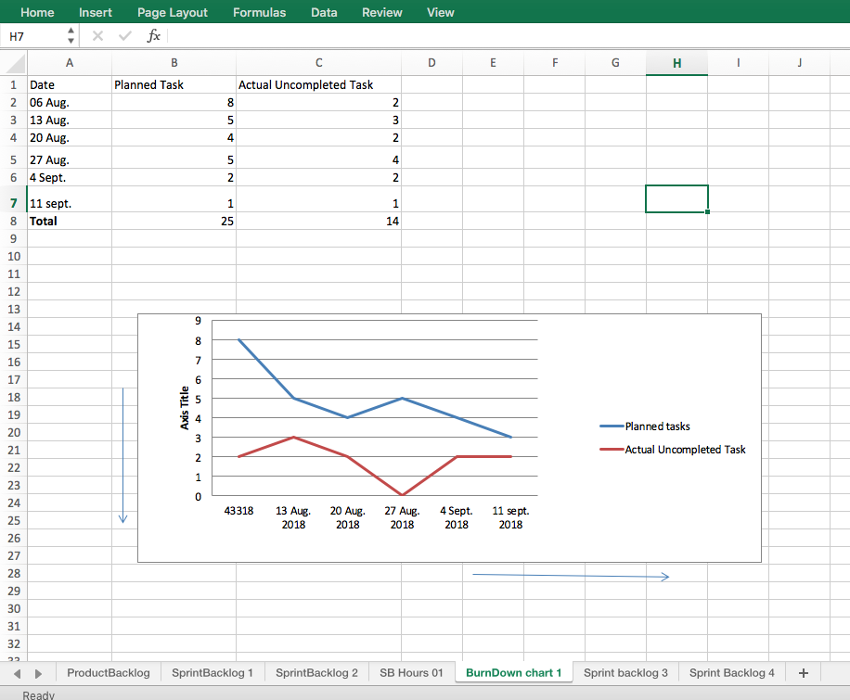
Figure 2.2

    - Sprint Backlog-1

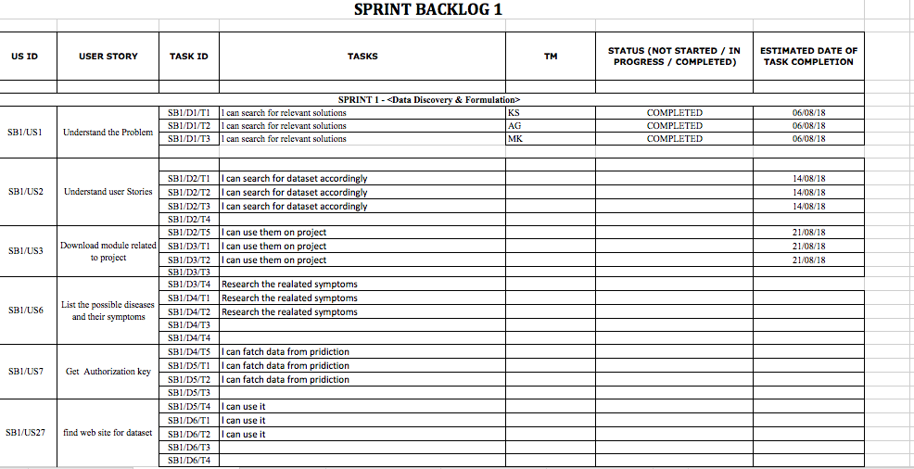
Figure 2.3

- Sprint Backlog-2

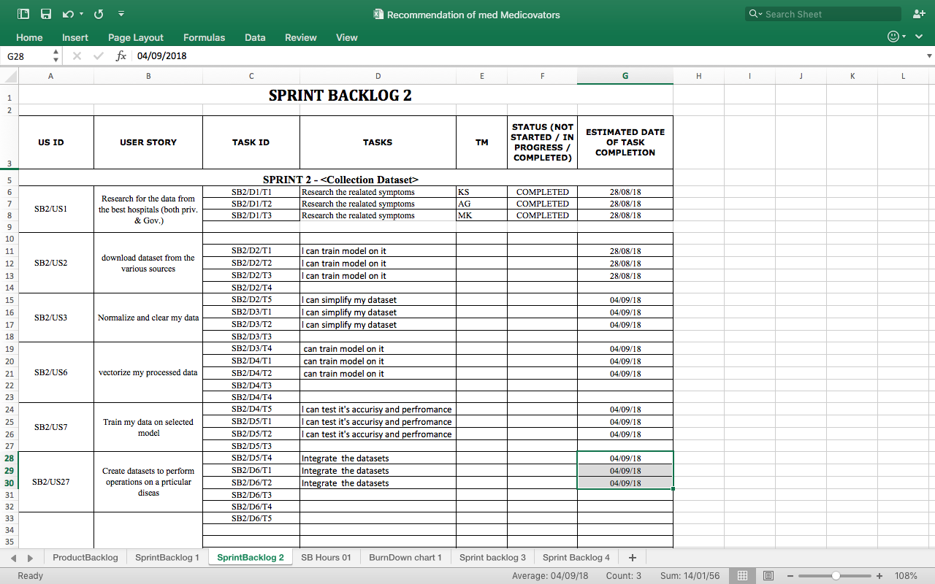
Figure 2.4

- Sprint Backlog-3

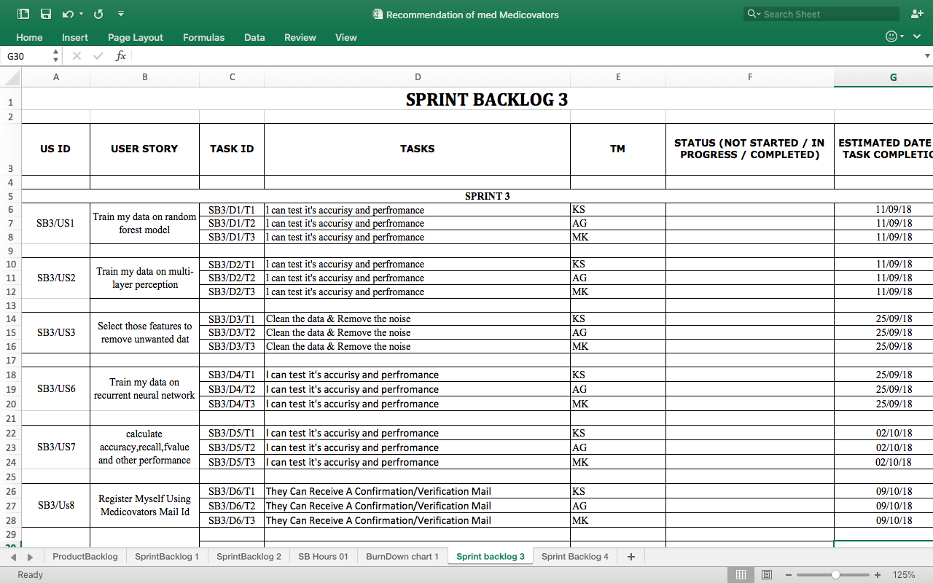
Figure 2.5

- Sprint Backlog-4

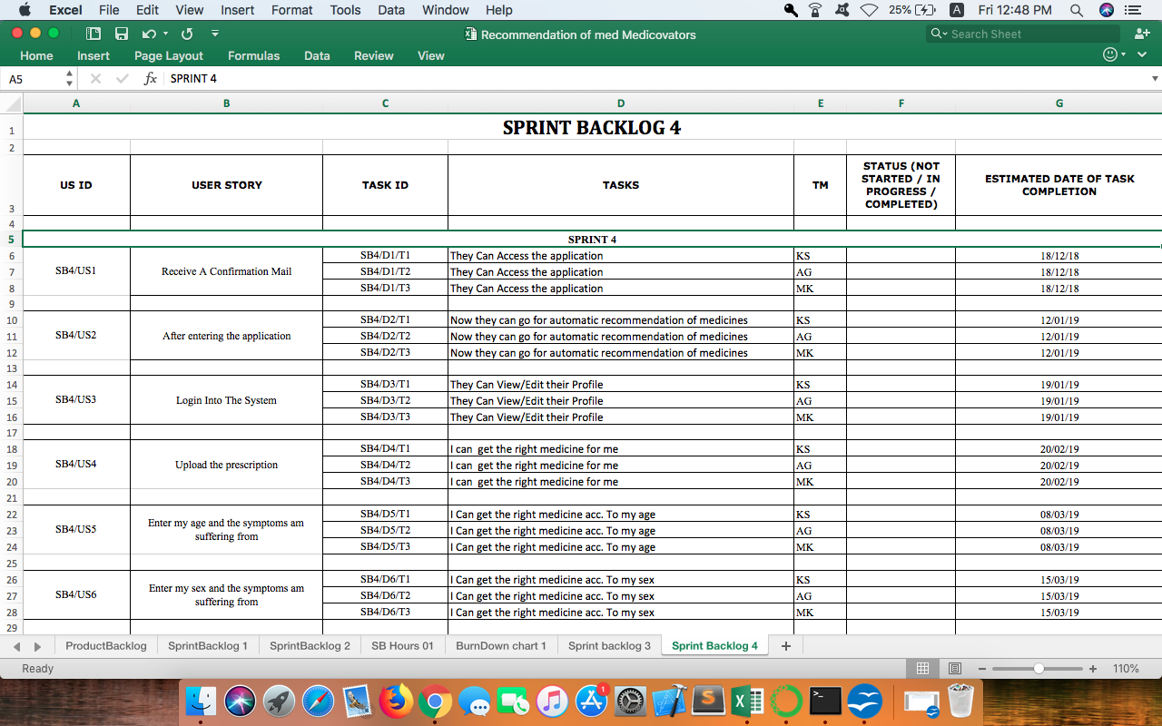
Figure 2.6

CHAPTER 3

TECHNOLOGY APPLIED AND PROJECT MANAGEMENT

Language Applied
Python is a general-purpose programming language that is becoming more and more popular for doing data science. Companies worldwide are using Python to harvest insights from their data and get a competitive edge. Unlike any other Python tutorial, this course focuses on Python specifically for data science. In our Intro to Python class, you will learn about powerful ways to store and manipulate data as well as cool data science tools to start your own analyses. Enter DataCamp’s online Python curriculum.
1.Simple Elegant Syntax
Programming in Python is fun. It's easier to understand and write Python code. Why?The syntax feels natural. Take this source code for an example:
a = 2
b = 3
sum = a + b
print(sum)
Even if you have never programmed before, you can easily guess that this program adds two numbers and prints it.
- Not overly strict
You don't need to define the type of a variable in Python. Also, it's not necessary to add semicolon at the end of the statement.
Python enforces you to follow good practices (like proper indentation). These small things can make learning much easier for beginners.
- Expressiveness of the language
Python allows you to write programs having greater functionality with fewer lines of code. Here's a link to the source code of Tic-tac-toe game with a graphical interface and a smart computer opponent in less than 500 lines of code. This is just an example. You will be amazed how much you can do with Python once you learn the basics.

An introduction to the basic concepts of Python. Learn how to use Python both interactively and through a script. Create your first variables and acquaint yourself with Python's basic data types.

Functions and Packages
To leverage the code that brilliant Python developers have written, you'll learn about using functions, methods and packages. This will help you to reduce the amount of code you need to solve challenging problems!

NumPy
NumPy is a Python package to efficiently do data science. Learn to work with the NumPy array, a faster and more powerful alternative to the list, and take your first steps in data exploration.

Features of Python Programming
- A simple language which is easier to learn
Python has a very simple and elegant syntax. It's much easier to read and write Python programs compared to other languages like: C++, Java, C#. Python makes programming fun and allows you to focus on the solution rather than syntax.
If you are a newbie, it's a great choice to start your journey with Python.
- Free and open-source
You can freely use and distribute Python, even for commercial use. Not only can you use and distribute softwares written in it, you can even make changes to the Python's source code.
Python has a large community constantly improving it in each iteration.
- Portability
You can move Python programs from one platform to another, and run it without any changes.
It runs seamlessly on almost all platforms including Windows, Mac OS X and Linux.
- Extensible and Embeddable
Suppose an application requires high performance. You can easily combine pieces of C/C++ or other languages with Python code.
This will give your application high performance as well as scripting capabilities which other languages may not provide out of the box.
- A high-level, interpreted language
Unlike C/C++, you don't have to worry about daunting tasks like memory management, garbage collection and so on.
Likewise, when you run Python code, it automatically converts your code to the language your computer understands. You don't need to worry about any lower-level operations.
- Large standard libraries to solve common tasks
Python has a number of standard libraries which makes life of a programmer much easier since you don't have to write all the code yourself. For example: Need to connect MySQL database on a Web server? You can use MySQLdb library using import MySQLdb .
Standard libraries in Python are well tested and used by hundreds of people. So you can be sure that it won't break your application.
- Object-oriented
Everything in Python is an object. Object oriented programming (OOP) helps you solve a complex problem intuitively.
With OOP, you are able to divide these complex problems into smaller sets by creating objects.

- Simple Elegant Syntax
Programming in Python is fun. It's easier to understand and write Python code. Why?The syntax feels natural. Take this source code for an example:
a = 2
b = 3
sum = a + b
print(sum)
Even if you have never programmed before, you can easily guess that this program adds two numbers and prints it.
- Not overly strict
You don't need to define the type of a variable in Python. Also, it's not necessary to add semicolon at the end of the statement.
Python enforces you to follow good practices (like proper indentation). These small things can make learning much easier for beginners.
- Expressiveness of the language
Python allows you to write programs having greater functionality with fewer lines of code. Here's a link to the source code of Tic-tac-toe game with a graphical interface and a smart computer opponent in less than 500 lines of code. This is just an example. You will be amazed how much you can do with Python once you learn the basics.

Syntax and semantics
Main article: Python syntax and semantics
Python is meant to be an easily readable language. Its formatting is visually uncluttered, and it often uses English keywords where other languages use punctuation. Unlike many other languages, it does not use curly brackets to delimit blocks, and semicolons after statements are optional. It has fewer syntactic exceptions and special cases than C or Pascal.

Indentation
Main article: Python syntax and semantics § Indentation
Python uses whitespace indentation, rather than curly brackets or keywords, to delimit blocks. An increase in indentation comes after certain statements; a decrease in indentation signifies the end of the current block.[59] Thus, the program's visual structure accurately represents the program's semantic structure.[1] This feature is also sometimes termed the off-side rule.

Statements and control flow
Python's statements include (among others):
- The assignment statement (token '=', the equals sign). This operates differently than in traditional imperative programming languages, and this fundamental mechanism (including the nature of Python's version of variables) illuminates many other features of the language. Assignment in C, e.g., x = 2, translates to "typed variable name x receives a copy of numeric value 2". The (right-hand) value is copied into an allocated storage location for which the (left-hand) variable name is the symbolic address. The memory allocated to the variable is large enough (potentially quite large) for the declared type. In the simplest case of Python assignment, using the same example, x = 2, translates to "(generic) name x receives a reference to a separate, dynamically allocated object of numeric (int) type of value 2." This is termed binding the name to the object. Since the name's storage location doesn't contain the indicated value, it is improper to call it a variable. Names may be subsequently rebound at any time to objects of greatly varying types, including strings, procedures, complex objects with data and methods, etc. Successive assignments of a common value to multiple names, e.g., x = 2; y = 2; z = 2 result in allocating storage to (at most) three names and one numeric object, to which all three names are bound. Since a name is a generic reference holder it is unreasonable to associate a fixed data type with it. However at a given time a name will be bound to some object, which will have a type; thus there is dynamic typing.
- The if statement, which conditionally executes a block of code, along with else and elif (a contraction of else-if).
- The for statement, which iterates over an iterable object, capturing each element to a local variable for use by the attached block.
- The while statement, which executes a block of code as long as its condition is true.
- The try statement, which allows exceptions raised in its attached code block to be caught and handled by except clauses; it also ensures that clean-up code in a finally block will always be run regardless of how the block exits.
- The raise statement, used to raise a specified exception or re-raise a caught exception.
- The class statement, which executes a block of code and attaches its local namespace to a class, for use in object-oriented programming.
- The def statement, which defines a function or method.
- The with statement, from Python 2.5 released on September 2006, which encloses a code block within a context manager (for example, acquiring a lock before the block of code is run and releasing the lock afterwards, or opening a file and then closing it), allowing Resource Acquisition Is Initialization (RAII)-like behavior and replaces a common try/finally idiom.
- The pass statement, which serves as a NOP. It is syntactically needed to create an empty code block.
- The assert statement, used during debugging to check for conditions that ought to apply.
- The yield statement, which returns a value from a generator function. From Python 2.5, yield is also an operator. This form is used to implement coroutines.
- The import statement, which is used to import modules whose functions or variables can be used in the current program. There are three ways of using import: import <module name> [as <alias>] or from <module name> import * or from <module name> import <definition 1> [as <alias 1>], <definition 2> [as <alias 2>], ....
- The print statement was changed to the print() function in Python 3.
Python does not support tail call optimization or first-class continuations, and, according to Guido van Rossum, it never will. However, better support for coroutine-like functionality is provided in 2.5, by extending Python's generators.[65] Before 2.5, generators were lazy iterators; information was passed unidirectionally out of the generator. From Python 2.5, it is possible to pass information back into a generator function, and from Python 3.3, the information can be passed through multiple stack levels.

Expressions
Some Python expressions are similar to languages such as C and Java, while some are not:
- Addition, subtraction, and multiplication are the same, but the behavior of division differs. There are two types of divisions in Python. They are floor division and integer division. Python also added the ** operator for exponentiation.
- From Python 3.5, the new @ infix operator was introduced. It is intended to be used by libraries such as NumPy for matrix multiplication.
- In Python, == compares by value, versus Java, which compares numerics by value and objects by reference. (Value comparisons in Java on objects can be performed with the equals() method.) Python's is operator may be used to compare object identities (comparison by reference). In Python, comparisons may be chained, for example a <= b <= c.
- Python uses the words and, or, not for its boolean operators rather than the symbolic &&, ||, ! used in Java and C.
- Python has a type of expression termed a list comprehension. Python 2.4 extended list comprehensions into a more general expression termed a generatorexpression.
- Anonymous functions are implemented using lambda expressions; however, these are limited in that the body can only be one expression.

- Conditional expressions in Python are written as x if c else (different in order of operands from the c ? x : y operator common to many other languages).

- Python makes a distinction between lists and tuples. Lists are written as [1, 2, 3], are mutable, and cannot be used as the keys of dictionaries (dictionary keys must be immutable in Python). Tuples are written as (1, 2, 3), are immutable and thus can be used as the keys of dictionaries, provided all elements of the tuple are immutable. The + operator can be used to concatenate two tuples, which does not directly modify their contents, but rather produces a new tuple containing the elements of both provided tuples. Thus, given the variable t initially equal to (1, 2, 3), executing t = t + (4, 5) first evaluates t + (4, 5), which yields (1, 2, 3, 4, 5), which is then assigned back to t, thereby effectively "modifying the contents" of t, while conforming to the immutable nature of tuple objects. Parentheses are optional for tuples in unambiguous contexts.

Python features sequence unpacking where multiple expressions, each evaluating to anything that can be assigned to (a variable, a writable property, etc.), are associated in the identical manner to that forming tuple literals and, as a whole, are put on the left hand side of the equal sign in an assignment statement. The statement expects an iterable object on the right hand side of the equal sign that produces the same number of values as the provided writable expressions when iterated through, and will iterate through it, assigning each of the produced values to the corresponding expression on the left.[74]
- Python has a "string format" operator %. This functions analogous to printf format strings in C, e.g. "spam=%s eggs=%d" % ("blah", 2) evaluates to "spam=blah eggs=2". In Python 3 and 2.6+, this was supplemented by the format() method of the str class, e.g. "spam={0} eggs={1}".format("blah", 2). Python 3.6 added "f-strings": blah = "blah"; eggs = 2; f'spam={blah} eggs={eggs}'.
- Python has various kinds of string literals:
  - Strings delimited by single or double quote marks. Unlike in Unix shells, Perl and Perl-influenced languages, single quote marks and double quote marks function identically. Both kinds of string use the backslash (\) as an escape character. String interpolation became available in Python 3.6 as "formatted string literals".
  - Triple-quoted strings, which begin and end with a series of three single or double quote marks. They may span multiple lines and function like here documents in shells, Perl and Ruby.
  - Raw string varieties, denoted by prefixing the string literal with an r. Escape sequences are not interpreted; hence raw strings are useful where literal backslashes are common, such as regular expressions and Windows-style paths. Compare "@-quoting" in C#.
- Python has array index and array slicing expressions on lists, denoted as a[key], a[start:stop] or a[start:stop:step]. Indexes are zero-based, and negative indexes are relative to the end. Slices take elements from the start index up to, but not including, the stop index. The third slice parameter, called step or stride, allows elements to be skipped and reversed. Slice indexes may be omitted, for example a[:] returns a copy of the entire list. Each element of a slice is a shallow copy.
In Python, a distinction between expressions and statements is rigidly enforced, in contrast to languages such as Common Lisp, Scheme, or Ruby. This leads to duplicating some functionality. For example:
- List comprehensions vs. for-loops
- Conditional expressions vs. if blocks
- The eval() vs. exec() built-in functions (in Python 2, exec is a statement); the former is for expressions, the latter is for statements.
Statements cannot be a part of an expression, so list and other comprehensions or lambda expressions, all being expressions, cannot contain statements. A particular case of this is that an assignment statement such as a = 1 cannot form part of the conditional expression of a conditional statement. This has the advantage of avoiding a classic C error of mistaking an assignment operator = for an equality operator == in conditions: if (c = 1) { ... } is syntactically valid (but probably unintended) C code but if c = 1: ... causes a syntax error in Python.

Methods
Methods on objects are functions attached to the object's class; the syntax instance.method(argument) is, for normal methods and functions, syntactic sugar for Class.method(instance, argument). Python methods have an explicit self parameter to access instance data, in contrast to the implicit self (or this) in some other object-oriented programming languages (e.g., C++, Java, Objective-C, or Ruby).

Typing
Python uses duck typing and has typed objects but untyped variable names. Type constraints are not checked at compile time; rather, operations on an object may fail, signifying that the given object is not of a suitable type. Despite being dynamically typed, Python is strongly typed, forbidding operations that are not well-defined (for example, adding a number to a string) rather than silently attempting to make sense of them.
Python allows programmers to define their own types using classes, which are most often used for object-oriented programming. New instances of classes are constructed by calling the class (for example, SpamClass() or EggsClass()), and the classes are instances of the metaclass type (itself an instance of itself), allowing metaprogramming and reflection.
Before version 3.0, Python had two kinds of classes: old-style and new-style. The syntax of both styles is the same, the difference being whether the class object is inherited from, directly or indirectly (all new-style classes inherit from object and are instances of type). In versions of Python 2 from Python 2.2 onwards, both kinds of classes can be used. Old-style classes were eliminated in Python 3.0.
The long term plan is to support gradual typing and from Python 3.5, the syntax of the language allows specifying static types but they are not checked in the default implementation, CPython. An experimental optional static type checker named mypy supports compile-time type checking.

Summary of Python 3's built-in types
Type | mutable | Description | Syntax example
bool | immutable | Boolean value | True  False
bytearray | mutable | Sequence of bytes | bytearray(b'Some ASCII')  bytearray(b"Some ASCII")  bytearray([119, 105, 107, 105])
bytes | immutable | Sequence of bytes | b'Some ASCII'  b"Some ASCII"  bytes([119, 105, 107, 105])
complex | immutable | Complex number with real and imaginary parts | 3+2.7j
dict | mutable | Associative array (or dictionary) of key and value pairs; can contain mixed types (keys and values), keys must be a hashable type | {'key1': 1.0, 3: False}
ellipsis |  | An ellipsis placeholder to be used as an index in NumPy arrays | ...
float | immutable | Floating point number, system-defined precision | 3.1415927
frozenset | immutable | Unordered set, contains no duplicates; can contain mixed types, if hashable | frozenset([4.0, 'string', True])
int | immutable | Integer of unlimited magnitude[80] | 42
list | mutable | List, can contain mixed types | [4.0, 'string', True]
set | mutable | Unordered set, contains no duplicates; can contain mixed types, if hashable | {4.0, 'string', True}
str | immutable | A character string: sequence of Unicode codepoints | 'Wikipedia'  "Wikipedia"  """Spanning  multiple  lines"""
tuple | immutable | Can contain mixed types | (4.0, 'string', True)

Mathematics
Table 3.1

Python has the usual C language arithmetic operators (+, -, *, /, %). It also has ** for exponentiation, e.g. 5**3 == 125 and 9**0.5 == 3.0, and a new matrix multiply @ operator is included in version 3.5.[81] Additionally, it has a unary operator (~), which essentially inverts all the bits of its one argument. For integers, this means ~x=-x-1.[82] Other operators include bitwise shift operators x << y, which shifts x to the left y places, the same as x*(2**y) , and x >> y, which shifts x to the right y places, the same as x//(2**y) .
- Python 2.1 and earlier use the C division behavior. The / operator is integer division if both operands are integers, and floating-point division otherwise. Integer division rounds towards 0, e.g. 7/3 == 2 and -7/3 == -2.
- Python 2.2 changes integer division to round towards negative infinity, e.g. 7/3 == 2 and -7/3 == -3. The floor division // operator is introduced. So 7//3 == 2, -7//3 == -3, 7.5//3 == 2.0 and -7.5//3 == -3.0. Adding from __future__ import division causes a module to use Python 3.0 rules for division (see next).
- Python 3.0 changes / to be always floating-point division. In Python terms, the pre-3.0 / is classic division, the version-3.0 / is real division, and // is floor division.
Rounding towards negative infinity, though different from most languages, adds consistency. For instance, it means that the equation (a + b)//b == a//b + 1 is always true. It also means that the equation b*(a//b) + a%b == a is valid for both positive and negative values of a. However, maintaining the validity of this equation means that while the result of a%b is, as expected, in the half-open interval [0, b), where b is a positive integer, it has to lie in the interval (b, 0] when b is negative.
Python provides a round function for rounding a float to the nearest integer. For tie-breaking, versions before 3 use round-away-from-zero: round(0.5) is 1.0, round(-0.5) is −1.0.Python 3 uses round to even: round(1.5) is 2, round(2.5) is 2.
Python allows boolean expressions with multiple equality relations in a manner that is consistent with general use in mathematics. For example, the expression a < b < c tests whether a is less than b and b is less than c.C-derived languages interpret this expression differently: in C, the expression would first evaluate a < b, resulting in 0 or 1, and that result would then be compared with c.
Python has extensive built-in support for arbitrary precision arithmetic. Integers are transparently switched from the machine-supported maximum fixed-precision (usually 32 or 64 bits), belonging to the python type int, to arbitrary precision, belonging to the Python type long, where needed. The latter have an "L" suffix in their textual representation. (In Python 3, the distinction between the int and long types was eliminated; this behavior is now entirely contained by the int class.) The Decimal type/class in module decimal (since version 2.4) provides decimal floating point numbers to arbitrary precision and several rounding modes. The Fraction type in module fractions (since version 2.6) provides arbitrary precision for rational numbers.
Due to Python's extensive mathematics library, and the third-party library NumPy that further extends the native capabilities, it is frequently used as a scientific scripting language to aid in problems such as numerical data processing and manipulation.[citation needed]

Libraries
Python's large standard library, commonly cited as one of its greatest strengths, provides tools suited to many tasks. For Internet-facing applications, many standard formats and protocols such as MIME and HTTP are supported. It includes modules for creating graphical user interfaces, connecting to relational databases, generating pseudorandom numbers, arithmetic with arbitrary precision decimals, manipulating regular expressions, and unit testing.
Some parts of the standard library are covered by specifications (for example, the Web Server Gateway Interface (WSGI) implementation wsgiref follows PEP 333), but most modules are not. They are specified by their code, internal documentation, and test suites (if supplied). However, because most of the standard library is cross-platform Python code, only a few modules need altering or rewriting for variant implementations.
As of March 2018, the Python Package Index (PyPI), the official repository for third-party Python software, contains over 130,000 packages with a wide range of functionality, including:
- Graphical user interfaces
- Web frameworks
- Multimedia
- Databases
- Networking
- Test frameworks
- Automation
- Web scraping
- Documentation
- System administration
- Scientific computing
- Text processing
- Image processing

Development environments

Most Python implementations (including CPython) include a read–eval–print loop (REPL), permitting them to function as a command line interpreter for which the user enters statements sequentially and receives results immediately.
Other shells, including IDLE and IPython, add further abilities such as auto-completion, session state retention and syntax highlighting.
As well as standard desktop integrated development environments, there are Web browser-based IDEs; SageMath (intended for developing science and math-related Python programs); PythonAnywhere, a browser-based IDE and hosting environment; and Canopy IDE, a commercial Python IDE emphasizing scientific computing.

Implementations
See also: List of Python software § Python implementations

Reference implementation
CPython is the reference implementation of Python. It is written in C, meeting the C89 standard with several select C99 features. It compiles Python programs into an intermediate bytecode[100] which is then executed by its virtual machine. CPython is distributed with a large standard library written in a mixture of C and native Python. It is available for many platforms, including Windows and most modern Unix-like systems. Platform portability was one of its earliest priorities.

Other implementations
PyPy is a fast, compliant interpreter of Python 2.7 and 3.5. Its just-in-time compiler brings a significant speed improvement over CPython.
Stackless Python is a significant fork of CPython that implements microthreads; it does not use the C memory stack, thus allowing massively concurrent programs. PyPy also has a stackless version.
MicroPython and CircuitPython are Python 3 variants optimised for microcontrollers.

Unsupported implementations
Other just-in-time Python compilers have been developed, but are now unsupported:
- Google began a project named Unladen Swallow in 2009 with the aim of speeding up the Python interpreter fivefold by using the LLVM, and of improving its multithreading ability to scale to thousands of cores.
- Psyco is a just-in-time specialising compiler that integrates with CPython and transforms bytecode to machine code at runtime. The emitted code is specialised for certain data types and is faster than standard Python code.
In 2005, Nokia released a Python interpreter for the Series 60 mobile phones named PyS60. It includes many of the modules from the CPython implementations and some additional modules to integrate with the Symbian operating system. The project has been kept up-to-date to run on all variants of the S60 platform, and several third-party modules are available. The Nokia N900 also supports Python with GTK widget libraries, enabling programs to be written and run on the target device.

Cross-compilers to other languages
There are several compilers to high-level object languages, with either unrestricted Python, a restricted subset of Python, or a language similar to Python as the source language:
- Jython compiles into Java byte code, which can then be executed by every Java virtual machine implementation. This also enables the use of Java class library functions from the Python program.
- IronPython follows a similar approach in order to run Python programs on the .NET Common Language Runtime.
- The RPython language can be compiled to C, Java bytecode, or Common Intermediate Language, and is used to build the PyPy interpreter of Python.
- Pyjs compiles Python to JavaScript.
- Cython compiles Python to C and C++.
- Pythran compiles Python to C++.
- Somewhat dated Pyrex (latest release in 2010) and Shed Skin (latest release in 2013) compile to C and C++ respectively.
- Google's Grumpy compiles Python to Go.
- MyHDL compiles Python to VHDL.
- Nuitka compiles Python into C++.

Performance
A performance comparison of various Python implementations on a non-numerical (combinatorial) workload was presented at EuroSciPy '13.

Development
Python's development is conducted largely through the Python Enhancement Proposal (PEP) process, the primary mechanism for proposing major new features, collecting community input on issues and documenting Python design decisions. Outstanding PEPs are reviewed and commented on by the Python community and Guido Van Rossum, Python's Benevolent Dictator For Life.
Enhancement of the language corresponds with development of the CPython reference implementation. The mailing list python-dev is the primary forum for the language's development. Specific issues are discussed in the Roundup bug tracker maintained at python.org. Development originally took place on a self-hostedsource-code repository running Mercurial, until Python moved to GitHub in January 2017.
CPython's public releases come in three types, distinguished by which part of the version number is incremented:
- Backward-incompatible versions, where code is expected to break and need to be manually ported. The first part of the version number is incremented. These releases happen infrequently—for example, version 3.0 was released 8 years after 2.0.
- Major or "feature" releases, about every 18 months, are largely compatible but introduce new features. The second part of the version number is incremented. Each major version is supported by bugfixes for several years after its release.
- Bugfix releases, which introduce no new features, occur about every 3 months and are made when a sufficient number of bugs have been fixed upstream since the last release. Security vulnerabilities are also patched in these releases. The third and final part of the version number is incremented.
Many alpha, beta, and release-candidates are also released as previews and for testing before final releases. Although there is a rough schedule for each release, they are often delayed if the code is not ready. Python's development team monitors the state of the code by running the large unit test suite during development, and using the BuildBot continuous integration system.
The community of Python developers has also contributed over 86,000 software modules (as of 20 August 2016) to the Python Package Index (PyPI), the official repository of third-party Python libraries.
The major academic conference on Python is PyCon. There are also special Python mentoring programmes, such as Pyladies.

Naming
Python's name is derived from the British comedy group Monty Python, whom Python creator Guido van Rossum enjoyed while developing the language. Monty Python references appear frequently in Python code and culture;[117] for example, the metasyntactic variables often used in Python literature are spam and eggs instead of the traditional foo and bar. The official Python documentation also contains various references to Monty Python routines.[
The prefix Py- is used to show that something is related to Python. Examples of the use of this prefix in names of Python applications or libraries include Pygame, a binding of SDL to Python (commonly used to create games); PyQt and PyGTK, which bind Qt and GTK to Python respectively; and PyPy, a Python implementation originally written in Python.

API documentation generators
Python API documentation generators include:
- Sphinx
- Epydoc
- HeaderDoc
- pydoc

Uses

Since 2003, Python has consistently ranked in the top ten most popular programming languages in the TIOBE Programming Community Index where, as of January 2018, it is the fourth most popular language (behind Java, C, and C++). It was selected Programming Language of the Year in 2007 and 2010.
An empirical study found that scripting languages, such as Python, are more productive than conventional languages, such as C and Java, for programming problems involving string manipulation and search in a dictionary, and determined that memory consumption was often "better than Java and not much worse than C or C++".[123]
Large organizations that use Python include Wikipedia, Google, Yahoo!, CERN, NASA, Facebook, Amazon, Instagram, Spotify and some smaller entities like ILM and ITA.] The social news networking site Reddit is written entirely in Python.
Python can serve as a scripting language for web applications, e.g., via mod_wsgi for the Apache web server. With Web Server Gateway Interface, a standard API has evolved to facilitate these applications. Web frameworks like Django, Pylons, Pyramid, TurboGears, web2py, Tornado, Flask, Bottle and Zope support developers in the design and maintenance of complex applications. Pyjs and IronPython can be used to develop the client-side of Ajax-based applications. SQLAlchemy can be used as data mapper to a relational database. Twisted is a framework to program communications between computers, and is used (for example) by Dropbox.
Libraries such as NumPy, SciPy and Matplotlib allow the effective use of Python in scientific computing, with specialized libraries such as Biopython and Astropyproviding domain-specific functionality. SageMath is a mathematical software with a "notebook" programmable in Python: its library covers many aspects of mathematics, including algebra, combinatorics, numerical mathematics, number theory, and calculus.
Python has been successfully embedded in many software products as a scripting language, including in finite element method software such as Abaqus, 3D parametric modeler like FreeCAD, 3D animation packages such as 3ds Max, Blender, Cinema 4D, Lightwave, Houdini, Maya, modo, MotionBuilder, Softimage, the visual effects compositor Nuke, 2D imaging programs like GIMP,[135] Inkscape, Scribus and Paint Shop Pro,[136] and musical notation programs like scorewriter and capella. GNU Debugger uses Python as a pretty printer to show complex structures such as C++ containers. Esri promotes Python as the best choice for writing scripts in ArcGIS.[137] It has also been used in several video games, ] and has been adopted as first of the three available programming languages in Google App Engine, the other two being Java and Go. Python is also used in algorithmic trading and quantitative finance Python can also be implemented in APIs of online brokerages that run on other languages by using wrappers.
Python has been used in artificial intelligence projects.[ As a scripting language with modular architecture, simple syntax and rich text processing tools, Python is often used for natural language processing.
Many operating systems include Python as a standard component. It ships with most Linux distributions, AmigaOS 4, FreeBSD, NetBSD, OpenBSD and macOS, and can be used from the command line (terminal). Many Linux distributions use installers written in Python: Ubuntu uses the Ubiquity installer, while Red Hat Linux and Fedorause the Anaconda installer. Gentoo Linux uses Python in its package management system, Portage.
Python is used extensively in the information security industry, including in exploit development.
Most of the Sugar software for the One Laptop per Child XO, now developed at Sugar Labs, is written in Python.
The Raspberry Pi single-board computer project has adopted Python as its main user-programming language.
LibreOffice includes Python, and intends to replace Java with Python. Its Python Scripting Provider is a core feature since Version 4.0 from 7 February 2013.

Machine Learning -

Figure 3.1
Machine learning is an application of artificial intelligence (AI) that provides systems the ability to automatically learn and improve from experience without being explicitly programmed. Machine learning focuses on the development of computer programs that can access data and use it learn for themselves.
The process of learning begins with observations or data, such as examples, direct experience, or instruction, in order to look for patterns in data and make better decisions in the future based on the examples that we provide. The primary aim is to allow the computers learn automatically without human intervention or assistance and adjust actions accordingly.

Some machine learning methods
Machine learning algorithms are often categorized as supervised or unsupervised.
- Supervised machine learning algorithms can apply what has been learned in the past to new data using labeled examples to predict future events. Starting from the analysis of a known training dataset, the learning algorithm produces an inferred function to make predictions about the output values. The system is able to provide targets for any new input after sufficient training. The learning algorithm can also compare its output with the correct, intended output and find errors in order to modify the model accordingly.
- In contrast, unsupervised machine learning algorithms are used when the information used to train is neither classified nor labeled. Unsupervised learning studies how systems can infer a function to describe a hidden structure from unlabeled data. The system doesn’t figure out the right output, but it explores the data and can draw inferences from datasets to describe hidden structures from unlabeled data.
- Semi-supervised machine learning algorithms fall somewhere in between supervised and unsupervised learning, since they use both labeled and unlabeled data for training – typically a small amount of labeled data and a large amount of unlabeled data. The systems that use this method are able to considerably improve learning accuracy. Usually, semi-supervised learning is chosen when the acquired labeled data requires skilled and relevant resources in order to train it / learn from it. Otherwise, acquiringunlabeled data generally doesn’t require additional resources.
- Reinforcement machine learning algorithms is a learning method that interacts with its environment by producing actions and discovers errors or rewards. Trial and error search and delayed reward are the most relevant characteristics of reinforcement learning. This method allows machines and software agents to automatically determine the ideal behavior within a specific context in order to maximize its performance. Simple reward feedback is required for the agent to learn which action is best; this is known as the reinforcement signal.
Machine learning enables analysis of massive quantities of data. While it generally delivers faster, more accurate results in order to identify profitable opportunities or dangerous risks, it may also require additional time and resources to train it properly. Combining machine learning with AI and cognitive technologies can make it even more effective in processing large volumes of information.

Machine learning applications :
A support vector machine is a classifier that divides its input space into two regions, separated by a linear boundary. Here, it has learned to distinguish black and white circles.
Another categorization of machine learning tasks arises when one considers the desired output of a machine-learned system.
- In classification, inputs are divided into two or more classes, and the learner must produce a model that assigns unseen inputs to one or more (multi-label classification) of these classes. This is typically tackled in a supervised way. Spam filtering is an example of classification, where the inputs are email (or other) messages and the classes are "spam" and "not spam".
- In regression, also a supervised problem, the outputs are continuous rather than discrete.
- In clustering, a set of inputs is to be divided into groups. Unlike in classification, the groups are not known beforehand, making this typically an unsupervised task.
- Density estimation finds the distribution of inputs in some space.
- Dimensionality reduction simplifies inputs by mapping them into a lower-dimensional space. Topic modeling is a related problem, where a program is given a list of human language documents and is tasked to find out which documents cover similar topics.
Among other categories of machine learning problems, learning to learn learns its own inductive bias based on previous experience. Developmental learning, elaborated for robot learning, generates its own sequences (also called curriculum) of learning situations to cumulatively acquire repertoires of novel skills through autonomous self-exploration and social interaction with human teachers and using guidance mechanisms such as active learning, maturation, motor synergies, and imitation.

Project management :

Project management is the application of processes, methods, knowledge, skills and experience to achieve the project objectives. General. A project is a unique, transient endeavor, undertaken to achieve planned objectives, which could be defined in terms of outputs, outcomes or benefits.

Project management is the practise of initiating, planning, executing, controlling, and closing the work of a team to achieve specific goals and meet specific success criteria at the specified time. A project is a temporary endeavor designed to produce a unique product, service or result with a defined beginning and end undertaken to meet unique goals and objectives, typically to bring about beneficial change or added value. The temporary nature of projects stands in contrast with business as usual, which are repetitive, permanent, or semi-permanent functional activities to produce products or services. In practice, the management of such distinct production approaches requires the development of distinct technical skills and management strategies.

Software project management
Software project management is the art and science of planning and leading software projects. It is a sub-discipline of project management in which software projects are planned, implemented, monitored and controlled.

The job pattern of an IT company engaged in software development can be seen split in two parts:
- Software Creation
- Software Project Management
A project is well-defined task, which is a collection of several operations done in order to achieve a goal (for example, software development and delivery). A Project can be characterized as:
- Every project may have a unique and distinct goal.
- Project is not routine activity or day-to-day operations.
- Project comes with a start time and end time.
- Project ends when its goal is achieved hence it is a temporary phase in the lifetime of an organization.
- Project needs adequate resources in terms of time, manpower, finance, material and knowledge-bank.

Software Project
A Software Project is the complete procedure of software development from requirement gathering to testing and maintenance, carried out according to the execution methodologies, in a specified period of time to achieve intended software product.

Need of software project management
Software is said to be an intangible product. Software development is a kind of all new stream in world business and there’s very little experience in building software products. Most software products are tailor made to fit client’s requirements. The most important is that the underlying technology changes and advances so frequently and rapidly that experience of one product may not be applied to the other one. All such business and environmental constraints bring risk in software development hence it is essential to manage software projects efficiently.

The image above shows triple constraints for software projects. It is an essential part of software organization to deliver quality product, keeping the cost within client’s budget constrain and deliver the project as per scheduled. There are several factors, both internal and external, which may impact this triple constrain triangle. Any of three factor can severely impact the other two.
Therefore, software project management is essential to incorporate user requirements along with budget and time constraints.

Software Project Manager
A software project manager is a person who undertakes the responsibility of executing the software project. Software project manager is thoroughly aware of all the phases of SDLC that the software would go through. Project manager may never directly involve in producing the end product but he controls and manages the activities involved in production.
A project manager closely monitors the development process, prepares and executes various plans, arranges necessary and adequate resources, maintains communication among all team members in order to address issues of cost, budget, resources, time, quality and customer satisfaction.
Let us see few responsibilities that a project manager shoulders -

Managing People
- Act as project leader
- Liaison with stakeholders
- Managing human resources
- Setting up reporting hierarchy etc.

Managing Project
- Defining and setting up project scope
- Managing project management activities
- Monitoring progress and performance
- Risk analysis at every phase
- Take necessary step to avoid or come out of problems
- Act as project spokesperson

Software Management Activities
Software project management comprises of a number of activities, which contains planning of project, deciding scope of software product, estimation of cost in various terms, scheduling of tasks and events, and resource management. Project management activities may include:
- Project Planning
- Scope Management
- Project Estimation

Project Planning
Software project planning is task, which is performed before the production of software actually starts. It is there for the software production but involves no concrete activity that has any direction connection with software production; rather it is a set of multiple processes, which facilitates software production. Project planning may include the following:

Scope Management
It defines the scope of project; this includes all the activities, process need to be done in order to make a deliverable software product. Scope management is essential because it creates boundaries of the project by clearly defining what would be done in the project and what would not be done. This makes project to contain limited and quantifiable tasks, which can easily be documented and in turn avoids cost and time overrun.
During Project Scope management, it is necessary to -
- Define the scope
- Decide its verification and control
- Divide the project into various smaller parts for ease of management.
- Verify the scope
- Control the scope by incorporating changes to the scope

Project Estimation
For an effective management accurate estimation of various measures is a must. With correct estimation managers can manage and control the project more efficiently and effectively.
Project estimation may involve the following:
- Software size estimation
Software size may be estimated either in terms of KLOC (Kilo Line of Code) or by calculating number of function points in the software. Lines of code depend upon coding practices and Function points vary according to the user or software requirement.
- Effort estimation
The managers estimate efforts in terms of personnel requirement and man-hour required to produce the software. For effort estimation software size should be known. This can either be derived by managers’ experience, organization’s historical data or software size can be converted into efforts by using some standard formulae.
- Time estimation
Once size and efforts are estimated, the time required to produce the software can be estimated. An effort required is segregated into sub categories as per the requirement specifications and interdependency of various components of software. Software tasks are divided into smaller tasks, activities or events by Work Breakthrough Structure (WBS). The tasks are scheduled on day-to-day basis or in calendar months.
The sum of time required to complete all tasks in hours or days is the total time invested to complete the project.
- Cost estimation
This might be considered as the most difficult of all because it depends on more elements than any of the previous ones. For estimating project cost, it is required to consider -
  - Size of software
  - Software quality
  - Hardware
  - Additional software or tools, licenses etc.
  - Skilled personnel with task-specific skills
  - Travel involved
  - Communication
  - Training and support

Project Estimation Techniques
We discussed various parameters involving project estimation such as size, effort, time and cost.Project manager can estimate the listed factors using two broadly recognized techniques

Decomposition Technique
This technique assumes the software as a product of various compositions.
There are two main models -
- Line of Code Estimation is done on behalf of number of line of codes in the software product.
- Function Points Estimation is done on behalf of number of function points in the software product.

Empirical Estimation Technique
This technique uses empirically derived formulae to make estimation.These formulae are based on LOC or FPs.
- Putnam Model
This model is made by Lawrence H. Putnam, which is based on Norden’s frequency distribution (Rayleigh curve). Putnam model maps time and efforts required with software size.
- COCOMO
COCOMO stands for COnstructiveCOstMOdel, developed by Barry W. Boehm. It divides the software product into three categories of software: organic, semi-detached and embedded.

Project Scheduling
Project Scheduling in a project refers to roadmap of all activities to be done with specified order and within time slot allotted to each activity. Project managers tend to define various tasks, and project milestones and they arrange them keeping various factors in mind. They look for tasks lie in critical path in the schedule, which are necessary to complete in specific manner and strictly within the time allocated. Arrangement of tasks which lies out of critical path are less likely to impact over all schedule of the project.
For scheduling a project, it is necessary to -
- Break down the project tasks into smaller, manageable form
- Find out various tasks and correlate them
- Estimate time frame required for each task
- Divide time into work-units
- Assign adequate number of work-units for each task
- Calculate total time required for the project from start to finish

Resource management
All elements used to develop a software product may be assumed as resource for that project. This may include human resource, productive tools and software libraries.
The resources are available in limited quantity and stay in the organization as a pool of assets. The shortage of resources hampers the development of project and it can lag behind the schedule. Allocating extra resources increases development cost in the end. It is therefore necessary to estimate and allocate adequate resources for the project.
Resource management includes -
- Defining proper organization project by creating a project team and allocating responsibilities to each team member
- Determining resources required at a particular stage and their availability
- Manage Resources by generating resource request when they are required and de-allocating them when they are no more needed.

Project Risk Management
Risk management involves all activities pertaining to identification, analysing and making provision for predictable and non-predictable risks in the project. Risk may include the following:
- Experienced staff leaving the project and new staff coming in.
- Change in organizational management.
- Requirement change or misinterpreting requirement.
- Under-estimation of required time and resources.
- Technological changes, environmental changes, business competition.

Risk Management Process
There are following activities involved in risk management process:
- Identification - Make note of all possible risks, which may occur in the project.
- Categorize - Categorize known risks into high, medium and low risk intensity as per their possible impact on the project.
- Manage - Analyze the probability of occurrence of risks at various phases. Make plan to avoid or face risks. Attempt to minimize their side-effects.
- Monitor - Closely monitor the potential risks and their early symptoms. Also monitor the effects of steps taken to mitigate or avoid them.

Project Execution & Monitoring
In this phase, the tasks described in project plans are executed according to their schedules.
Execution needs monitoring in order to check whether everything is going according to the plan. Monitoring is observing to check the probability of risk and taking measures to address the risk or report the status of various tasks.
These measures include -
- Activity Monitoring - All activities scheduled within some task can be monitored on day-to-day basis. When all activities in a task are completed, it is considered as complete.
- Status Reports - The reports contain status of activities and tasks completed within a given time frame, generally a week. Status can be marked as finished, pending or work-in-progress etc.
- Milestones Checklist - Every project is divided into multiple phases where major tasks are performed (milestones) based on the phases of SDLC. This milestone checklist is prepared once every few weeks and reports the status of milestones.

Project Communication Management
Effective communication plays vital role in the success of a project. It bridges gaps between client and the organization, among the team members as well as other stake holders in the project such as hardware suppliers.
Communication can be oral or written. Communication management process may have the following steps:
- Planning - This step includes the identifications of all the stakeholders in the project and the mode of communication among them. It also considers if any additional communication facilities are required.
- Sharing - After determining various aspects of planning, manager focuses on sharing correct information with the correct person on correct time. This keeps every one involved the project up to date with project progress and its status.
- Feedback - Project managers use various measures and feedback mechanism and create status and performance reports. This mechanism ensures that input from various stakeholders is coming to the project manager as their feedback.
- Closure - At the end of each major event, end of a phase of SDLC or end of the project itself, administrative closure is formally announced to update every stakeholder by sending email, by distributing a hardcopy of document or by other mean of effective communication.
After closure, the team moves to next phase or project.

Configuration Management
Configuration management is a process of tracking and controlling the changes in software in terms of the requirements, design, functions and development of the product.
IEEE defines it as “the process of identifying and defining the items in the system, controlling the change of these items throughout their life cycle, recording and reporting the status of items and change requests, and verifying the completeness and correctness of items”.
Generally, once the SRS is finalized there is less chance of requirement of changes from user. If they occur, the changes are addressed only with prior approval of higher management, as there is a possibility of cost and time overrun.

Project management Tools:
Project management required tools to manage the work , time and resources. At present many of the software are available for project management. Some of the popular software tools are as follows.

01. Trello
Trello is an project management tool, instead this app is a free visual way to to glance at the entire project with a single view. With Trello you can organise cards, these cards can be your thoughts, conversations and to-do lists and be placed on a board for everyone to collaborate on.

02. Basecamp
Basecamp is the granddaddy of project management apps. Basecamp is considered the leading project management tool around. It boost a simple and easy to use interface to collaborate with your team and client. It allows you to create multiple projects and setup discussions, write to-do lists, manage files, create and share documents, and organise dates for scheduling.

03. Teamwork Projects
Teamwork Projects is the ultimate productivity tool to manage projects with your team. Teamwork allows you to keep all your projects, tasks and files all in one place and easily collaborate with a team. Teamwork helps you to visualise the entire project through a marked calendar and gantt chart and setup reporting. Teamwork supports file management with Google Drive, Box.com and Dropbox. As well as integration with leading apps such as third party accounting software and customer support apps.

04. Resource Guru
Billed as the "simple way to schedule people, equipment and other resources", Resource Guru is a streamlined resource scheduling and leave management tool that’s designed to keep your projects on track. You can plan your team's workloads, receive daily booking reminders, report on KPIs, and more. Apple, Saatchi & Saatchi and Deloitte are among some of the cloud-based team calendar’s heavyweight customers.

05. ActiveCollab
ActiveCollab recently released its new version 5.0. The new revamped app is now more powerful and focused project management tool. It offers team collaborating features, task management, time tracking and importing expenses. One of the biggest asset of ActiveCollab is it offers invoicing features. You are able to track payments and expenses and have invoices paid directly within ActiveCollab with PayPal, and other credit card payments.

06. Zoho Projects
Zoho offers a wide range of business software including Projects. Zoho Projects is an proficient tool to project plan and project coordinator from start to finish. It boost all the features you need for project management with some advance features including reporting, integration with Google Apps and Dropbox, bug tracking, setup Wiki Pages to build a repository of information, forums and more.

07. Jira
Jira is specifically targeted for software development teams. Jira offers abilities to raise issues and bugs. Jira makes it real easy to track bugs and see which issues are still outstanding and how much time was spent on each task. Jira offer other products including Confluence a document collaboration tool, and HipChat a team chat and video and file sharing platform and other products.

08. Asana
Asana is the easiest way for teams to track their work so everyone knows who's doing what, by when. With tasks, projects, conversations and dashboards, Asana keeps your work organized, and teammates accountable so you can move work forward faster. Asana also lets you keep track of your work wherever you are with mobile apps for both iOS and Android.

09. Podio
Podio is a ever growing tool to organise and communication tool for any business. Podio allows you to personalise this platform to fit your business needs. Besides being able to communicate with a team, setup task management, use as a file storage system, like a traditional project management app, Podio can be an internal intranet for all your colleagues and departments to interact.

10. Freedcamp
Whatever your project may be, either setting up an event, a web project or organising a wedding, Freedcamp helps you organise and plan effectively. Freedcamp has an organised dashboard to view the entire project at a glance. You can easily setup tasks, use sticky notes to visually setup tasks and organise them into the calendar. Freedcamp provides advance add-ons for high level business use including CRM, invoicing, issue tracking and setting up wiki pages.

11. Wrike
Wrike is advance application to help you work smarter. By making sure you are always staying on track and ensure you have the adequate resources to finish on time and on budget.Setting up tasks, engage your team and integrate with your business tools including Google Apps, Microsoft Excel, Dropbox and many more is so easy with Wrike.

PO and Their Relevance to project
PO1: Engineering knowledge:Apply the knowledge of mathematics, science, engineering fundamentals and an engineering specialization to the solution of complex engineering problems.
In this project creation process engineering knowledge of the software engineering and Electronics engineering have been applied. we have used software engineering , HTML,xml, java , android , java script , php , j2ee, data base , oracle , my sql , mango and other programming language and database to the project. We have applied all above engineering subjects in our projects.
PO2: Problem analysis:Identify, formulate, review research literature, and analyze complex engineering problems reaching substantiated conclusions using first principles of mathematics, natural sciences, and engineering sciences.

In our projects we have identified an problem , once verified by the client we have worked to identify the solution using all of our theoretical and practical knowledge.
PO3: Design/development of solutions: Design solutions for complex engineering problems and design system components or processes that meet the specified needs with appropriate consideration for the public health and safety, and the cultural, societal, and environmental considerations.

PO4: Conduct investigations of complex problems: Use research-based knowledge and research methods including design of experiments, analysis and interpretation of data, and synthesis of the information to provide valid conclusions.

PO5: Modern tool usage:Create, select, and apply appropriate techniques, resources, and modern engineering and IT tools including prediction and modeling to complex engineering activities with an understanding of the limitations.

In the project development we have applied Integrated Development Environment IDE for the rapid development of the code, used web server for the software development.

PO6: The engineer and society: Apply reasoning informed by the contextual knowledge to assess societal, health, safety, legal and cultural issues and the consequent responsibilities relevant to the professional engineering practice.
In 1961 , the Conference of Engineering Societies of Western Europe and the United States of America defined "professional engineer" as follows.
A professional engineer is competent by virtue of his/her fundamental education and training to apply the scientific method and outlook to the analysis and solution of engineering problems. He/she is able to assume personal responsibility for the development and application of engineering science and knowledge, notably in research, design, construction, manufacturing, superintending, managing and in the education of the engineer. His/her work is predominantly intellectual and varied and not of a routine mental or physical character. It requires the exercise of original thought and judgement and the ability to supervise the technical and administrative work of others. His/her education will have been such as to make him/her capable of closely and continuously following progress in his/her branch of engineering science by consulting newly published works on a worldwide basis, assimilating such information and applying it independently. He/she is thus placed in a position to make contributions to the development of engineering science or its applications. His/her education and training will have been such that he/she will have acquired a broad and general appreciation of the engineering sciences as well as thorough insight into the special features of his/her own branch. In due time he/she will be able to give authoritative technical advice and to assume responsibility for the direction of important tasks in his/her branch.

PO7: Environment and sustainability: Understand the impact of the professional engineering solutions in and environmental contexts, and demonstrate the knowledge of, and need for sustainable development.
Sustainability is the ability to continue a defined behavior indefinitely. Sometimes environmental, social and economic are termed to be the three pillars of sustainability.
PO8: Ethics: Apply ethical principles and commit to professional ethics and responsibilities and norms of the engineering practice
The ethics of engineers and the fundamental principles for Engineers are as follows.
Engineers uphold and advance the integrity, honor and dignity of the engineering profession by:
I. using their knowledge and skill for the enhancement of human welfare;
II.being honest and impartial, and servicing with fidelity the public, their employers and clients;
III. Striving to increase the competence and prestige of the engineering profession; and
IV. Supporting the professional and technical societies of their disciplines.
PO9. Individual and team work: Function effectively as an individual and as a member or leader in diverse teams, and in multidisciplinary settings.
To work successful in team a team member must have following capabilities.
1. The Ability to Listen
it is important to listen to one another's ideas. Too often in a business setting, you have a group of people simply waiting for their turn to speak, not paying one iota of attention to the persons on their left or right. So it is a good teamwork skill to have the ability to listen
2. Check Your Ego
This isn't saying abandon your ego all together, because that isn't healthy. But leaving your ego at the door temporarily is a very important team work skill. The reason this is so essential is because there is always someone better than you at something, no matter how brilliant you are.
3. Critique
By critique, I mean constructive criticism. Be able to give others constructive criticism and be able to listen to others critique your ideas and work. There shouldn't be any offense taken to constructive criticism. You all want to succeed, and this is a vital step in doing so.
4. Delegation
The mentality must be applied to teamwork. Delegate roles to those who do them best.
5. Show Respect
If you and another person happen to be paired up and can't stand each other, you can still put that aside for a couple of hours, treat each other civilly, and complete the tasks at hand. You may even overcome the dislike toward one another.
6. Be Helpful
This is simple.If one of your teammates does not understand an idea, discussion, or task that is being completed, take the necessary time to explain it to them and work with them. There are no weak links when everyone helps one another. Some take longer to learn than others, but that doesn't mean that they are of less intelligence. If in a meeting someone asks a question because they don't understand, don't frown at them. Just answer the questions patiently and concisely.
7. Question One Another
If someone brings up a topic of discussion and a solution to this topic, question them. Respectfully question, don't badger. Rather, ask them how it will work, why it will work over the long-run, and how everyone else can implement the idea.
8. Participation
Have the entire team encourage shy people to engage in the topics of discussion. Don't demand it, but make them realize that you really want to hear their ideas.
9. Rational Debate
Bad ideas are bad for teams. Spirited, friendly, rational debate is where facts come forward, ideas are born, and quality rises to the top.
10. Set The Right Environment
Try to make the space in which your team is assembled as comfortable, relaxing, and inviting as possible. You do not want your team to be tense and with frayed nerves.

PO 10: Communication:Communicate effectively on complex engineering activities with the engineering community and with society at large, such as, being able to comprehend and write effective reports and design documentation, make effective presentations, and give and receive clear instructions.
PO11: Project management and finance:Demonstrate knowledge and understanding of the engineering management principles and apply these to one’s own work, as a member and leader in a team, to manage projects and in multidisciplinary environments.
Project management is the application of processes, methods, knowledge, skills and experience to achieve the project objectives. In general project is a unique, transient endeavour, undertaken to achieve planned objectives, which could be defined in terms of outputs, outcomes or benefits.
PO12: Life-long learning: Recognize the need for and have the preparation and ability to engage in independent and lifelong learning in the broadest context of technological change.
Life Long Learning means is the provision or use of both formal and informal learning opportunities throughout people's lives in order to foster the continuous development and improvement of the knowledge and skills needed for employment and personal fulfillment

CHAPTER 4

PROJECT IMPLEMENTATION

- Sprint Backlog-1
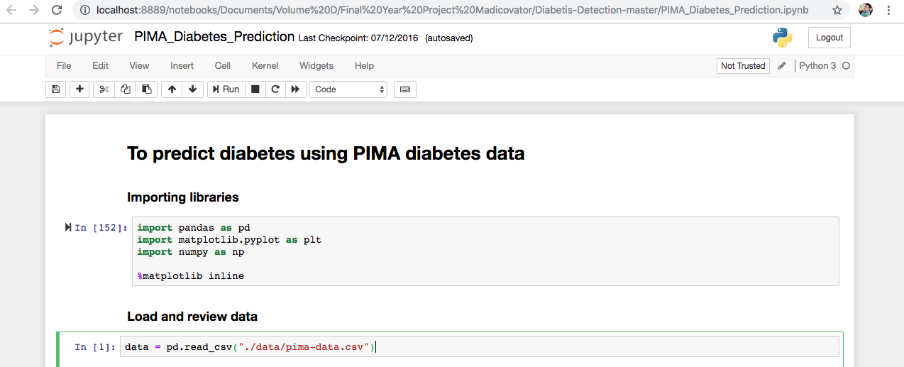
figure 4.1

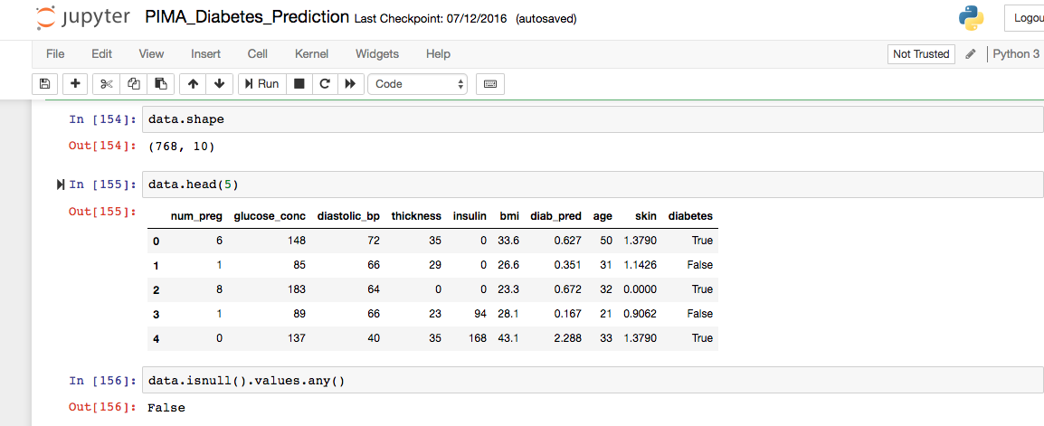
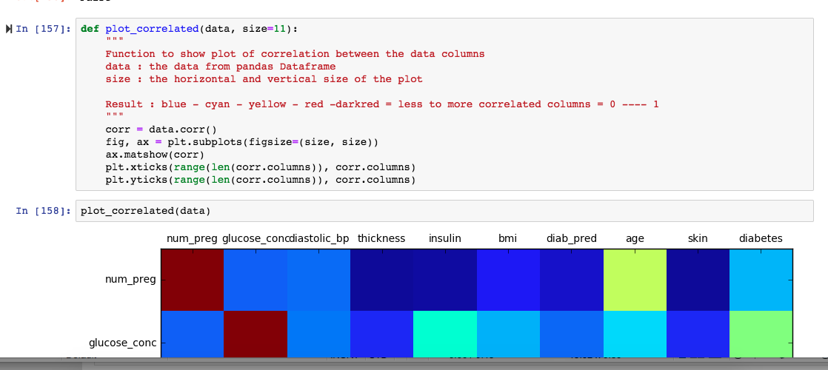
figure 4.2

figure 4.3

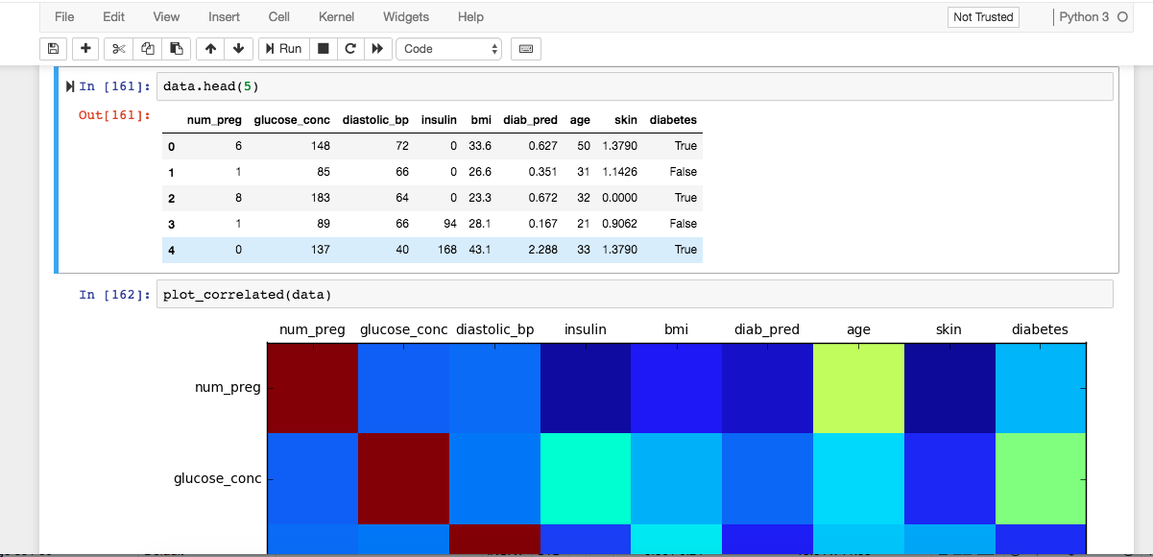
- Sprint Backlog-2

figure 4.4

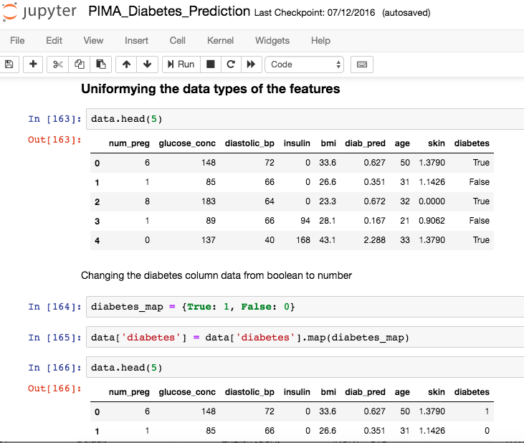

figure 4.5

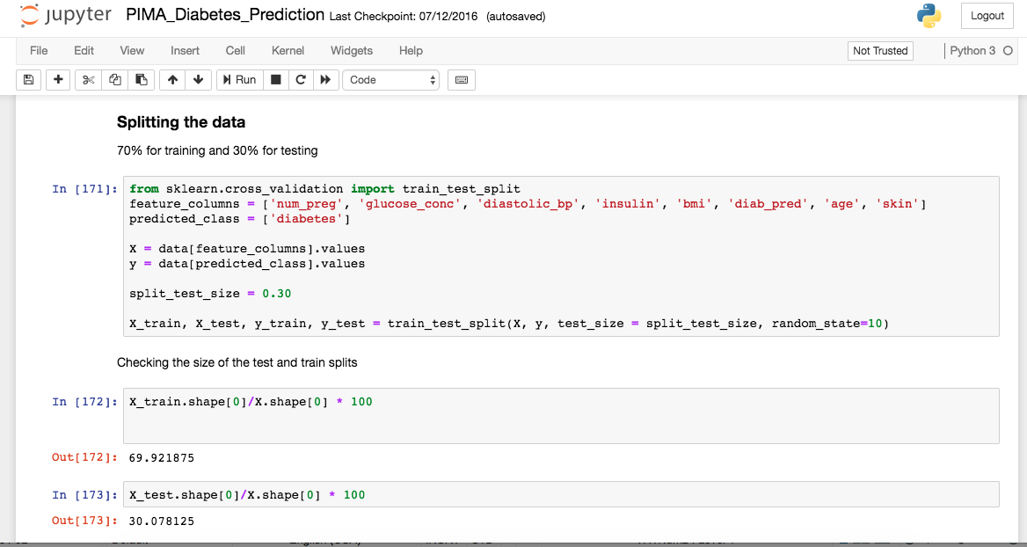
figure 4.6

- Sprint Backlog-3
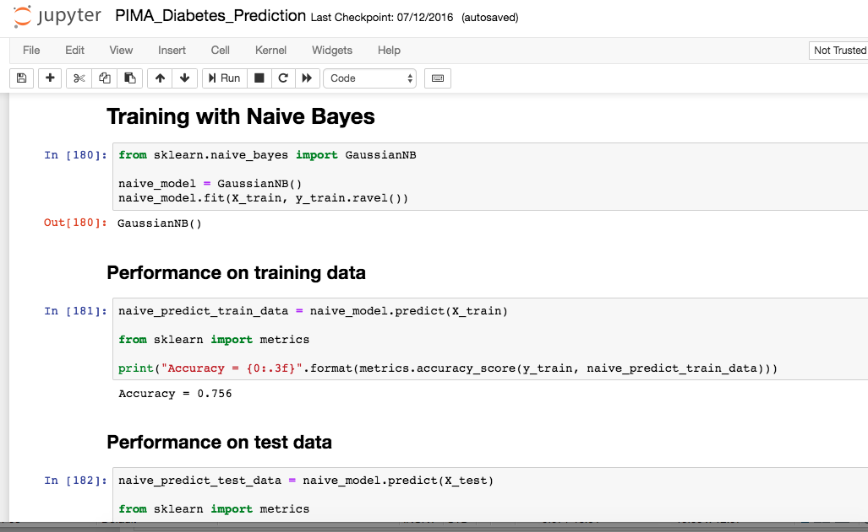
figure 4.7

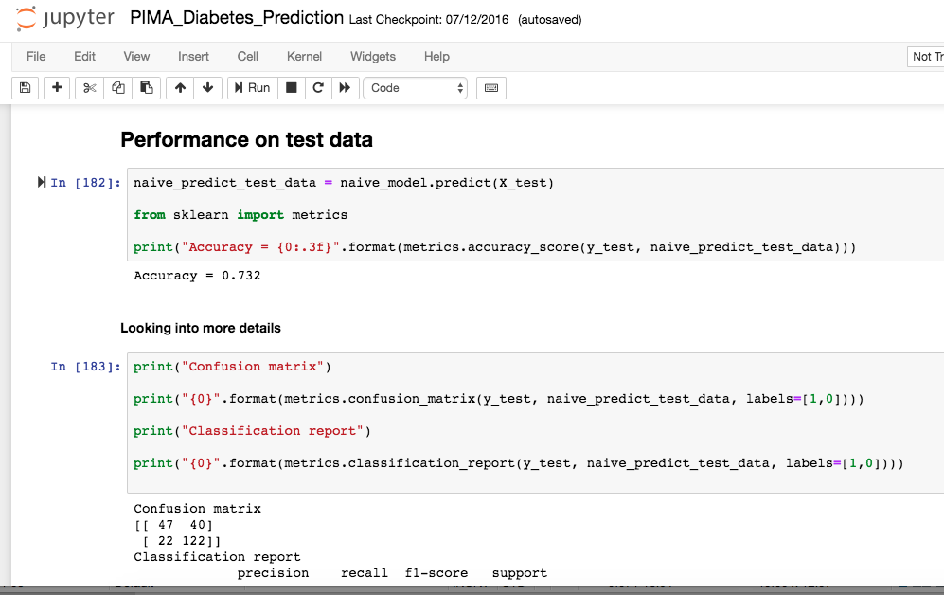

figure 4.8
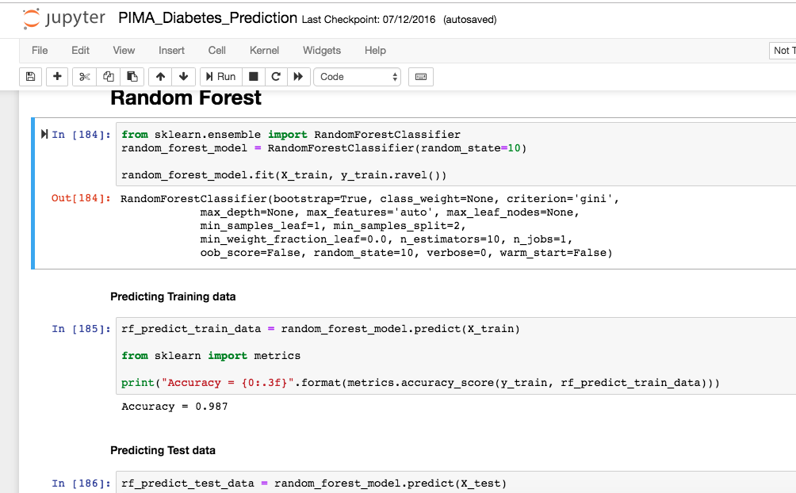

figure 4.9

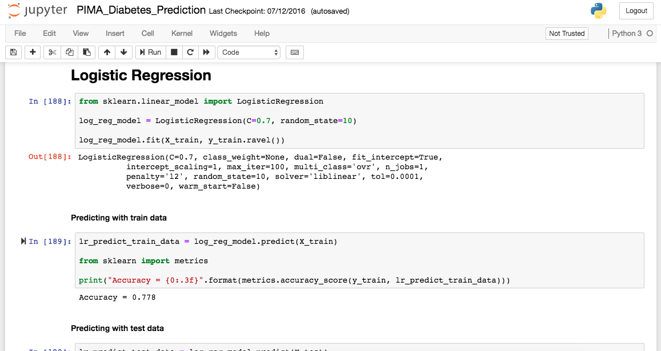

figure 4.10

Conclusion
CHAPTER 5

Results :-
After completed this project patient will fine the name of medicine. the medicine on online with any discuss doctors. Users are enter own problem and symptoms and age, gender and physical attributes and find which medicine is requirement of a particular patient problem.

Conclusion:-

This chapter has provided a definition and history of the field of health services research and discussed how this field is examining quality-of-care issues and seeking to improve quality of care. Comparisons of current practice to evidence-based standards with feedback to clinicians and the integration of patient-reported outcomes are two examples of how HSR tools can be used to provide quality-improvement information for health care organizations. These examples utilize multiple data sources, including medical records, patient surveys, and administrative data. The opportunities for nurse researchers to provide invaluable contributions to the growing field of health services research are innumerable.

Diagnosis is a very complicated process, and involves – at least for now – a myriad of factors (everything from the color of whites of a patient’s eyes to the food they have for breakfast) of which machines cannot presently collate and make sense; however, there’s little doubt that a machine might aid in helping physicians make the right considerations in diagnosis and treatment, simply by serving as an extension of scientific knowledge.
That’s what Memorial Sloan Kettering (MSK)’s Oncology department is aiming for in its recent partnership with IBM Watson. MSK has reams of data on cancer patients and treatments used over decades, and it’s able to present and suggest treatment ideas or options to doctors in dealing with unique future cancer cases – by pulling from what worked best in the past. The kind of an intelligence-augmenting tool, while difficult to sell into the hurly-burly world of hospitals, is already in preliminary use today.

Scaled Up / Crowdsourced Medical Data Collection
There is a great deal of focus on pooling data from various mobile devices in order to aggregate and make sense of more live health data. Apple’s ResearchKit is aiming to do this in the treatment of Parkinson’s disease and Asperger’s syndrome by allowing users to access interactive apps (one of which applies machine learning for facial recognition) that assess their conditions over time; their use of the app feeds ongoing progress data into an anonymous pool for future study.
IBM is going to great lengths to acquire all the health data it can get its hands on, from partnering with Medtronic to make sense of diabetes and insulin data in real time, to buying out healthcare analytics company Truven Health for $2.6B.
Despite the tremendous deluge of healthcare data provided by the internet of things, the industry still seems to be experimenting in how to make sense of this information and make real-time changes to treatment. Scientists and patients alike can be optimistic that, as this trend of pooled consumer data continues, researchers will have more ammunition for tackling tough diseases and unique cases.

Drug Discovery
While much of the healthcare industry is a morass of laws and criss-crossing incentives of various stakeholders (hospital CEOs, doctors, nurses, patients, insurance companies, etc…), drug discovery stands out as a relatively straightforward economic value for machine learning healthcare application creators. This application also deals with one relatively clear customer who happens to generally have deep pockets: drug companies.
IBM’s own health applications has had initiatives in drug discovery since it’s early days. Google has also jumped into the drug discovery fray and joins a host of companies already raising and making money by working on drug discovery with the help of machine learning.
We’ve covered drug discovery and pharma applications in greater depth elsewhere on TechEmergence. Many of our investor interviews (including our interview titled “Doctors Don’t Want to be Replaced” with Steve Gullans of Excel VM) feature a relatively optimistic outlook about the speed of innovation in drug discovery vs many other healthcare applications (see our list of “unique obstacles” to medical machine learning in the conclusion of this article).

Robotic Surgery
The da Vinci robot has gotten the bulk of attention in the robotic surgery space, and some could argue for good reason. This device allows surgeons to manipulate dextrous robotic limbs in order to perform surgeries with fine detail and in tight spaces (and with less tremors) than would be possible by the human hand alone.

Future Scope:-

Patient Safety: Patients should not be harmed by health care services that are intended to help them. The IOM report, To Err Is Human,26 found that between 46,000 and 98,000 Americans were dying in hospitals each year due to medical errors. Subsequent research has found medical errors common across all health care settings. The problem is not due to the lack of dedication to quality care by health professionals, but due to the lack of systems that prevent errors from occurring and/or prevent medical errors from reaching the patient.

1. Effectiveness: Effective care is based on scientific evidence that treatment will increase the likelihood of desired health outcomes. Evidence comes from laboratory experiments, clinical research (usually randomized controlled trials), epidemiological studies, and outcomes research. The availability and strength of evidence varies by disorder and treatment.

- Timeliness: Seeking and receiving health care is frequently associated with delays in obtaining an appointment and waiting in emergency rooms and doctors’ offices. Failure to provide timely care can deny people critically needed services or allow health conditions to progress and outcomes to worsen. Health care needs to be organized to meet the needs of patients in a timely manner.

- Patient Centered: Patient-centered care recognizes that listening to the patient’s needs, values, and preferences is essential to providing high-quality care. Health care services should be personalized for each patient, care should be coordinated, family and friends on whom the patient relies should be involved, and care should provide physical comfort and emotional support.

- Efficiency: The U.S. health care system is the most expensive in the world, yet there is consistent evidence that the United States does not produce the best health outcomes27–30 or the highest levels of satisfaction.31 The goal is to continually identify waste and inefficiency in the provision of health care services and eliminate them.

- Equity: The health care system should benefit all people. The evidence is strong and convincing that the current system fails to accomplish this goal. The IOM report, Unequal Treatment,32 documented pervasive differences in the care received by racial and ethnic minorities. The findings were that racial and ethnic minorities are receiving poorer quality of care than the majority population, even after accounting for differences in access to health services.

ANNEXURES

References:-
        - http://www.fda.gov/Safety/MedWatch/
        - Wiesner, Martin, and Daniel Pfeifer. “Health Recommender Systems: Concepts, Requirements, Technical Basics and Challenges.” International Journal of Environmental Research and Public Health 11.3 (2014): 2580–2607. PMC. Web. 18 Apr. 2018.
        - http://www.nlm.nih.gov/medlineplus
        - http://www.informedhealthonline.org

Instructions

For Chapter Heading
Font: Times New Roman
Font Size: 14, Bold
Alignment: Center
Line Spacing 1.5

For Paragraph Heading
Font: Times New Roman
Font Size: 12, Bold
Alignment: Left
Line Spacing 1.5

For paragraph
Font: Times New Roman
Font Size: 12
Line Spacing 1.5
Alignment: Justify
Line Spacing 1.5

